DAY 2 TEST QUESTIONS

1.Find the Number of Integers Divisible by 5

Program:

#include <stdio.h>

int main()

{

int i, num1, num2, count = 0, sum = 0;

printf("Enter the value of num1 and num2 \n");

scanf("%d %d", &num1, &num2);

printf("Integers divisible by 5 are \n");

for (i = num1; i < num2; i++)

{

if (i % 5 == 0)

{

printf("%3d,", i);

count++;

sum = sum + i;

}

}

printf("\n Number of integers divisible by 5 between %d and %d = %d\n", num1, num2, count);

printf("Sum of all integers that are divisible by 5 = %d\n", sum);

}

Output:

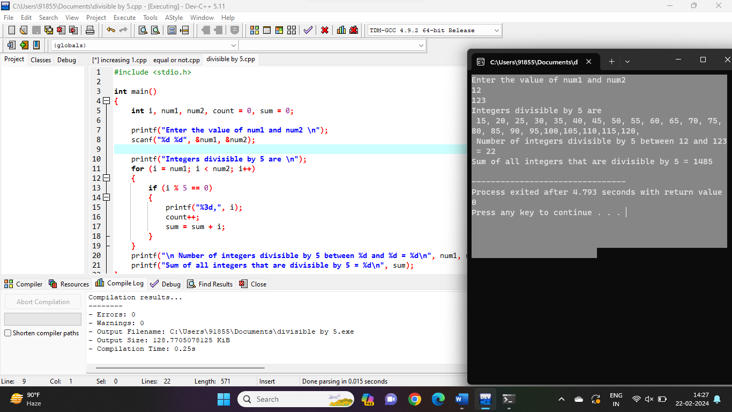

2. Check if Two Numbers are Equal

Program:

#include <stdio.h>

int main()

{

int m, n;

printf("Enter the values for M and N\n");

scanf("%d %d", &m, &n);

if (m == n)

printf("M and N are equal\n");

else

printf("M and N are not equal\n");

}

Output:

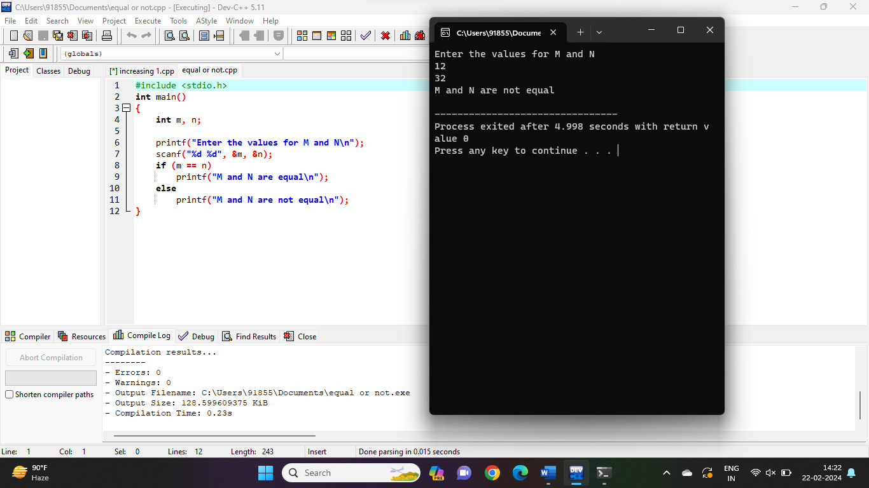

3.Find the Sum of Digits

Program:

#include <stdio.h>

int main(void)

{

int num, sum = 0, rem;

printf("Enter a number: ");

scanf("%d", &num);

while (num != 0)

{

rem = num % 10;

sum = sum + rem;

num = num / 10;

}

printf("Sum of digits of the number is %d", sum);

return 0;

}

Output:

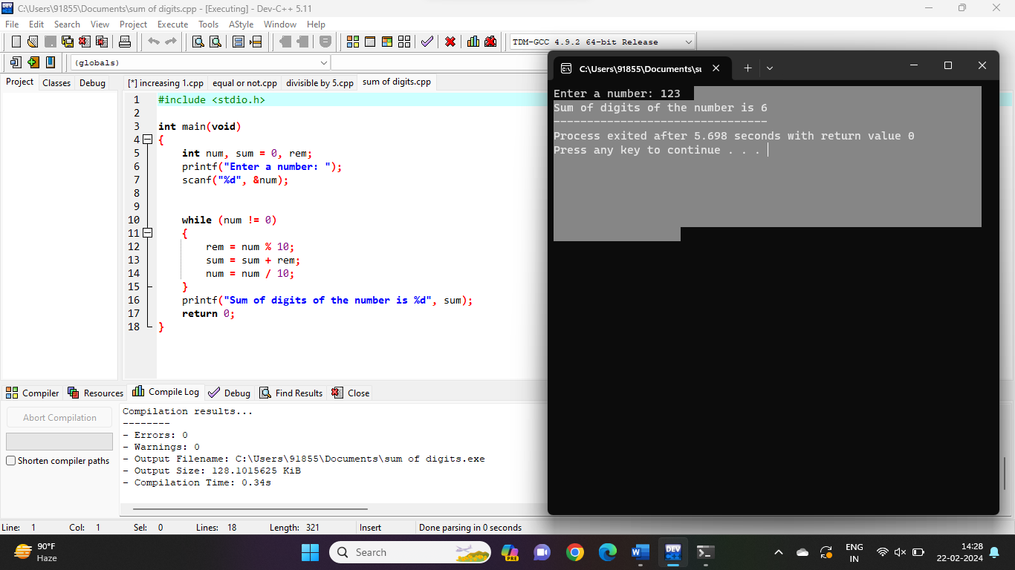

4.Increment by 1 to all the digits of a given integer

Program:

#include <stdio.h>

int main()

{

int number, sum = 0, remainder, count;

printf("Enter a number: ");

scanf("%d", &number);

while (number)

{

remainder = number % 10;

sum = sum + (remainder + 1);

number /= 10;

}

printf("increasing 1 to all digits: %d", sum);

return 0;

}

Output:

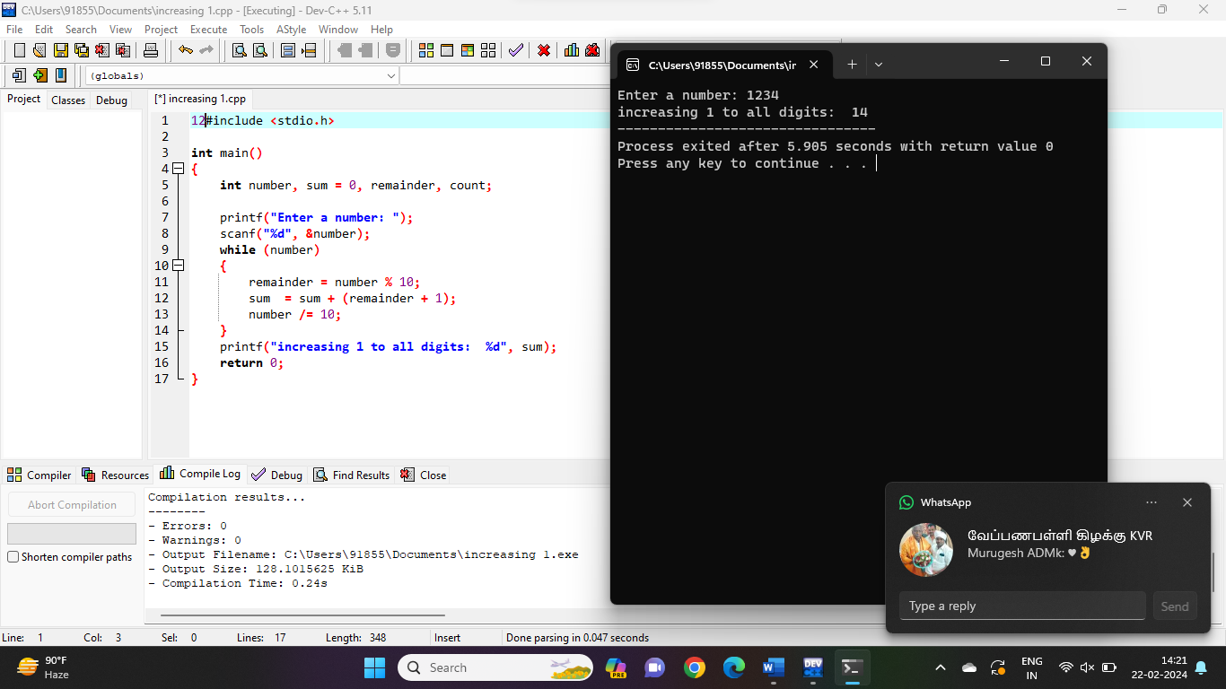

5.A multiplication table number ranging from 1 to 10

Program:

#include <stdio.h>

int main() {

int n;

printf("Enter an integer: ");

scanf("%d", &n);

for (int i = 1; i <= 10; ++i) {

printf("%d \* %d = %d \n", n, i, n \* i);

}

return 0;

}

Output:

